ATTENTION ALL BUS DRIVERS!!!!
PBIS Bus Materials
- BUS Expectations Matrix – Please tape this on your bus for everyone to see.
- Bus Bucks – You may hand these out, but please do not overdo it. If you hand out too many, it loses its value. The students may redeem these at their school.
- Shout Out Award – You are strongly encouraged to hand these out. However, these CANNOT be redeemed at the schools. You will have to reward the student.

Thank you for being an Active PBIS Participant!
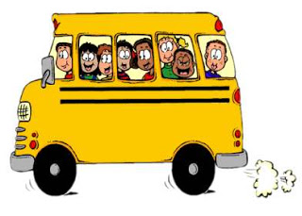
“Success is the Expectation”

