CCHS PBIS EXPECTATIONS BY SETTING:
Remember: Be Ready! Be Respectful! Be Responsible!

 | Arrival,  Departure, &  Parking Lot | Labs &  Media Center | Front Office | Cafeteria | Hallways &  Commons Area
Ready | - First thing, Front door  - Dress for Success  - Bring all Materials  - Punctual | - Punctual  - Expect Success, Set Goals  - Bring Materials to Class  - Regular Attendance | - Know Your Purpose | - Know your Menu Choice  - Know your Lunch #  - Know your Funds | 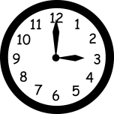  - Manage Time  - Bathroom before Classroom
Respectful | - Respect All  - Use Crosswalk/  Sidewalks | - Meet Classroom Expectations  - Respect All  - Cell Phone Etiquette | - Inside Voices  - Respect All | - Inside Voices  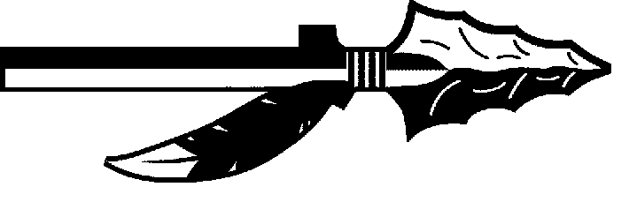  - Respect All  - Stay in Line | - Inside Voices  - Respect All  - Keep Moving to Destination
Responsible | - Wait in Designated Area  - Drive Responsible  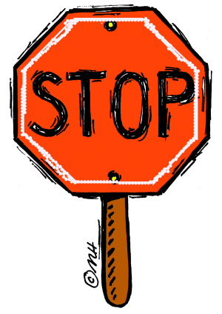  - Self Awareness  - Keep it Clean | - Be Accountable  - Prepared and on Task  - Follow Classroom Rules | - Bring a Pass  - Get a Pass  - Back to Class | - Keep it Clean  - Follow Café Procedures | - Keep it Clean  - Walk

